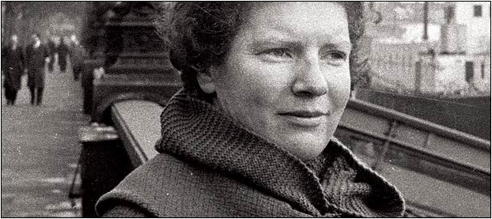

**Frame, Janet (1924-2004)**

Janet Frame is a notable author from New Zealand with a prolific literary career and a dramatic personal history. Like Frame’s own life, her writing frequently addresses poverty, marginalisation, and the artist’s struggle in a conformist society. Both her prose and poetry combine elements of modernism with magical realism.

Janet Paterson Frame was born in Dunedin, South Island as the third of five children in a working class family. Interestingly, her mother once served as a housemaid to the family of writer Katherine Mansfield and later wrote poems to sell door to door. During her childhood, two of Frame’s sisters drowned in separate incidents and her brother had severe epilepsy.

In 1943, Frame attended Dunedin College of Education to become a teacher. After a suicide attempt at university, she was misdiagnosed with schizophrenia and spent eight years in mental hospitals in New Zealand, including the notorious Seacliff Lunatic Asylum, where she received a multitude of electroshock treatments. In 1952, while Frame was in the asylum, New Zealand’s Caxton Press published her collection of short fiction titled *The Lagoon and Other Stories*, which was awarded a prestigious national literary prize. At the time, she was scheduled to have a lobotomy until hospital officials discovered that she had won the award. This discovery led to her release from the hospital and an eventual reversal of the schizophrenia diagnosis. Frame, however, was not pleased by this reversal, writing in her autobiography “Oh why had they robbed me of my schizophrenia, which had been the answer to all my misgivings about myself?”

Upon release from the hospital, Frame stayed with writer Frank Sargeson in Aukland, where she composed her first novel *Owls Do Cry* (1957), drawing extensively from her family tragedies and her time in the asylum. Frame then traveled abroad in Europe and published five more novels. She returned to New Zealand in 1964 and wrote more novels and three volumes of autobiography. Frame’s autobiography sold better than any of her previous publications and was adapted into an award-winning feature film *An Angel at My Table*. In total, Frame was the author of twelve novels, four short story collections, one book of poetry, and three volumes of autobiography.

She has won a wide range of awards and her writing has garnered numerous literary prizes and critical attention. In 1983, Frame became a Commander of the Order of British Empire for services to literature. In 1990, she was made a member of the Order of New Zealand, the country’s highest civil honour.

**Selected List of Works:**

Novels:

*Owls Do Cry (*1957)

*The Rainbirds* (1968)

*The Carpathians* (1988)

Short Stories:

*The Lagoon and other stories* (1951)

*You Are Now Entering the Human Heart* (1983)

**References and Further Reading:**

Delbaere, J, ed. (1992) *The Ring of Fire: Essays on Janet Frame*, Aarhus: Dangaroo Press.

Frame, J. (1991) *An Autobiography*, New York: George Braziller.

King, M. (2000) *Wrestling with the Angel: A Life of Janet Frame*, New Zealand: Penguin.